**ROMINIMAL**

Interface Design Report

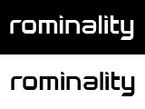

Larisa Ailisoaie

Razvan Bertea

Andrei Stefan Atudorei

Character Count: 37307 (with images)

Delivery date: 18.12.2019

Table of content - Interface Design

**Introduction of the project** **3**

The idea 3

Why Rominality? 3

Competitor Analysis 3

Mind Map 4

**The User** **4**

Target Audience 4

Personas 5

**User Interface & User Experience** **6**

Sitemap 6

Sketches 7

Wireframes 7

Paper-prototype 9

**Design Brief** **10**

Moodboard 11

Evolution of the Logo 11

Style Tile 14

Mock Ups 16

**Testing** **17**

5 Seconds Test 18

Expert Review Test - Landing Page 19

Card Sorting Test 19

System Usability Scale 19

**The Website** **21**

**Technologies** **21**

**Concussions** **21**

**Bibliography** **22**

# Introduction of the project

## The idea

Music lovers all over the world have access to multiple streaming services that focus on all types of genres. However, there is a gap in the industry when it comes to the ever growing genre of Rominimal. Rominimal is described as a minimalistic, groovy, deep and vibrant sound that moves through your body. Streaming services and music applications such as Tidal, Spotify and Apple music have little to no Rominimal sound available to users.

Rominiality is here to change that. The web community functions as a web application which is dedicated to rominimal music lovers. The app provides the user the opportunity to listen to rominimal music, like and comment on uploads and buy the song. As a producer, you are able to upload and sell your music and increase visibility throughout the community.

## Why Rominality?

The style, Rominimal has been around since the early 2000’s (Sof, 2019) but really started to emerge after 2007.

In April of 2007, Sunwaves, a now highly attended techno festival held their first of many yearly events. Since then, it has become one of Romania’s oldest and most respected festivals with a growing attendance of over 60,000 (Mihai, 2017).

With the lack of availability, we decided to solve the problem and create a platform for both users and producers. Producers desire a platform where they can post their music for users to buy and listen too and users crave the subtle ethereal sounds Rominimal has to offer.

## Competitor Analysis

Based on personal experiences and previous research, Rominiality has one direct hidden competitor - <http://ro-minimal.info/>. We say hidden because it is very difficult to find and lacks visually representation to what defines Rominimal. The website is very slow and appears to be broken as many things are overlapping and the media quests aren't working properly.

Indirect competitors such as Spotify, Drooble, SoundCloud and Apple Music are focused on a wide variety of genres from Hip Hop to Rock and Country to Electronic. These platforms share many things in common, including their lack of underground music.

Rominality is creating the bridge of being able to listen to underground music easily and making it accessible to users worldwide.

## Mind Map

A mind map is a diagram in which information is represented visually, usually with a central idea placed in the middle and associated ideas arranged around it. We used it as a brainstorming tool in order to better understand the concept of our digital solution and have a clearer understanding of the website plan. This mind map was created in the beginning and it includes also future improvements and features.

[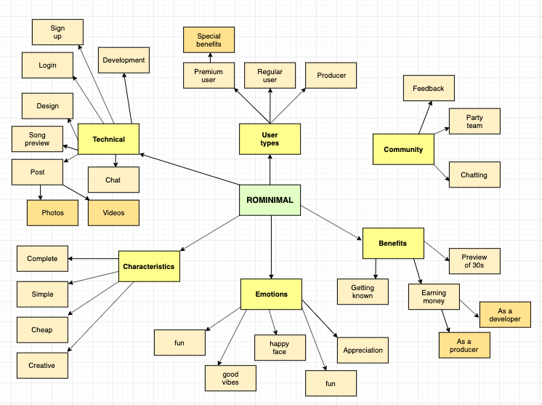](https://xd.adobe.com/view/7f674044-b77b-436e-4365-5d1a449c0419-0956/)

# The User

## Target Audience

Rominality’s target audience is between the ages of 18 to 40 whom appreciate simple and groovy tunes which aren’t found on popular streamlining platforms. They are students or working class professionals who enjoy social events, meeting and connecting with others and discovering new music. They are both male and female however the main demographic is men.

Statistics show that millennials needed a genre to call their own and because rock and hip-hop were taken by their parents - they were left with electronic dance music (Burns,2014).

Between millennials and techno/electronic music it’s a match made in marketing heaven. In the last three years, the attendance of millennials at music festivals has nearly doubled. Now is the time to create such a platform as the genre is gaining recognition worldwide (Grate, 2017).

Another important factor is the flourishing economy over the past years, a factor that increased the average income for a millennial, and taking into consideration that a very big number of them are still living with their parents, they have more money to spend on music and support their favourite artists (Friedman, 2018).

Another very important factor and great aspect is that they are relying on music more for a better workday. According to Digital Music News, the millennial generation listens to 75.1% more music on a daily basis than baby boomers. Music has been important to every generation that came before, but millennials are particularly enamoured with it (Landrum, 2017).

## Personas

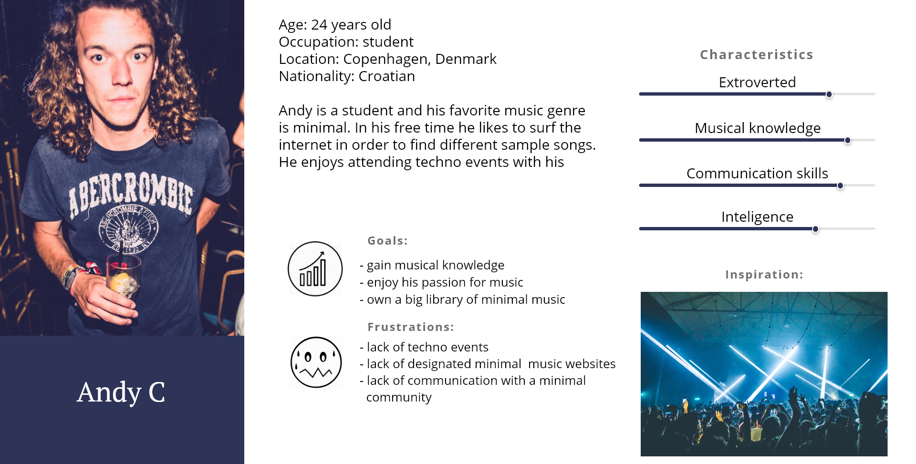

## 

## 

# User Interface & User Experience

## Sitemap

## 

## 

## 

## 

## 

## Sketches

In order to define initial sketches we did research on similar websites to see how they showcased their content. After we created a basic idea of what we want our web community to contain, we completed a card sorting test. This is to make sure that the potential user has all the necessary information to be satisfied and have a clear and strong understanding of the digital solution. A more in-depth analysis of the card sorting test will be further explained later on in the testing section.

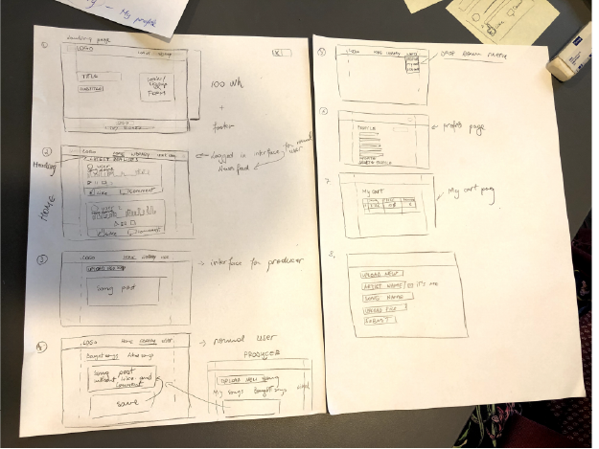

## Wireframes

Based on users needs, we created a basic wireframe which is used for planning a site's structure and functionality. Based on this visual representation of a user interface the paper prototype was done for a good and correct flow of the digital solution.

1. Desktop version   
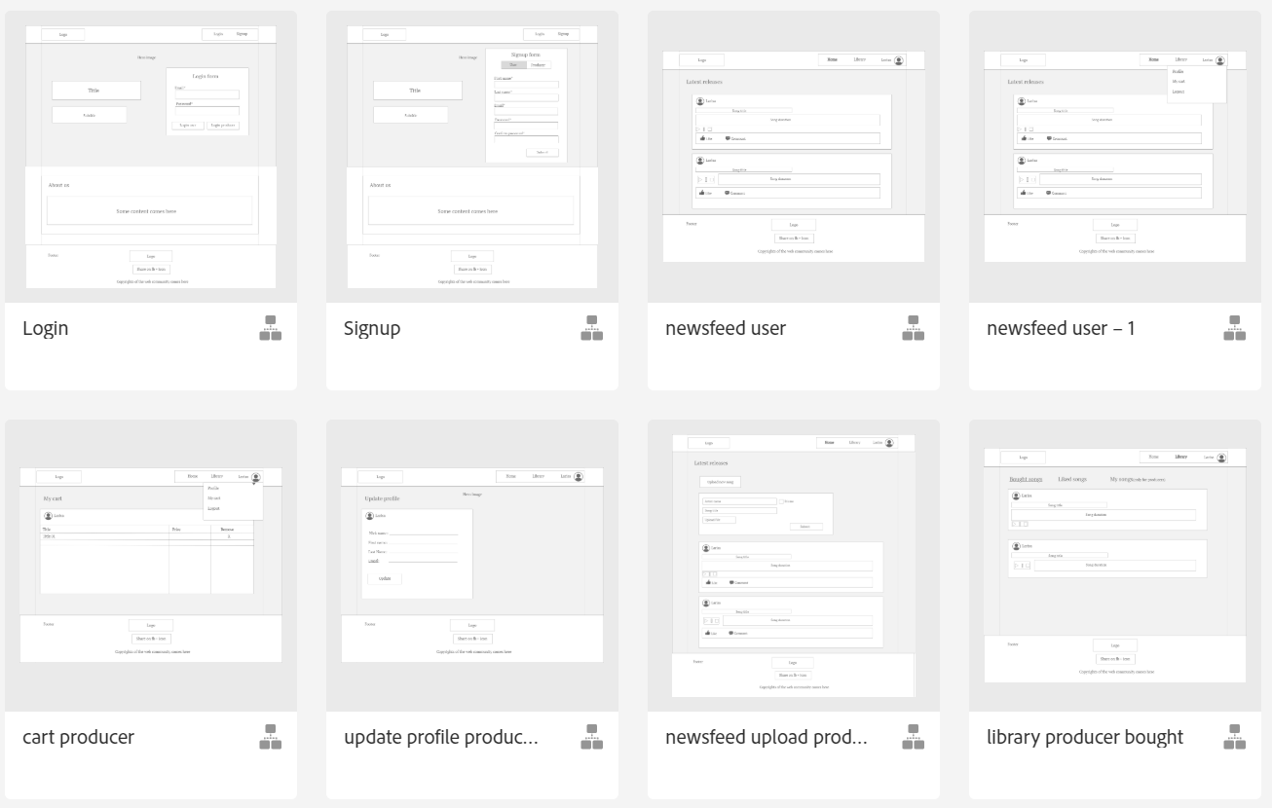

1. Mobile version

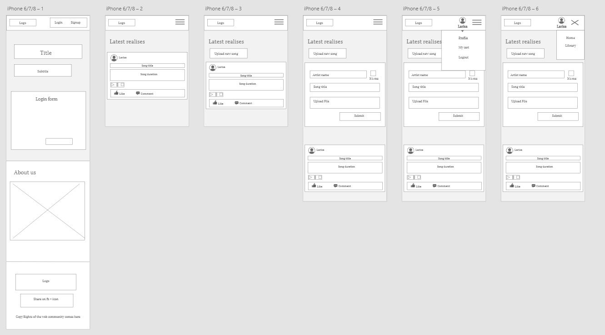

During the development and after doing more user testing, some of the element’s positioning or functionality were improved, but the main skeleton and idea stays similar.

## Paper-prototype

Paper prototypes were created to be used for usability testing with real users that we can make sure that perform realistic tasks by interacting with it. In addition, paper prototype is part of the design development. It’s used for the usability of the website, but at the same time it is a start for real prototypes/design ideas.

Link to the full XD paper-prototype :

<https://xd.adobe.com/view/7f674044-b77b-436e-4365-5d1a449c0419-0956/>

1. Desktop version

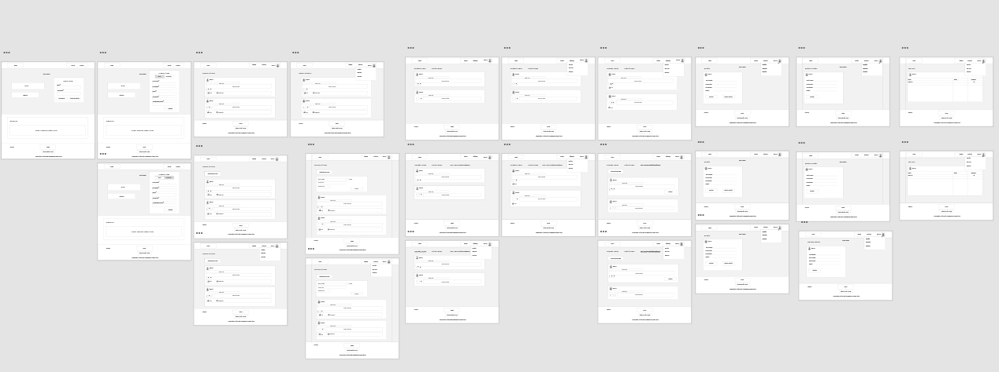

1. Mobile version

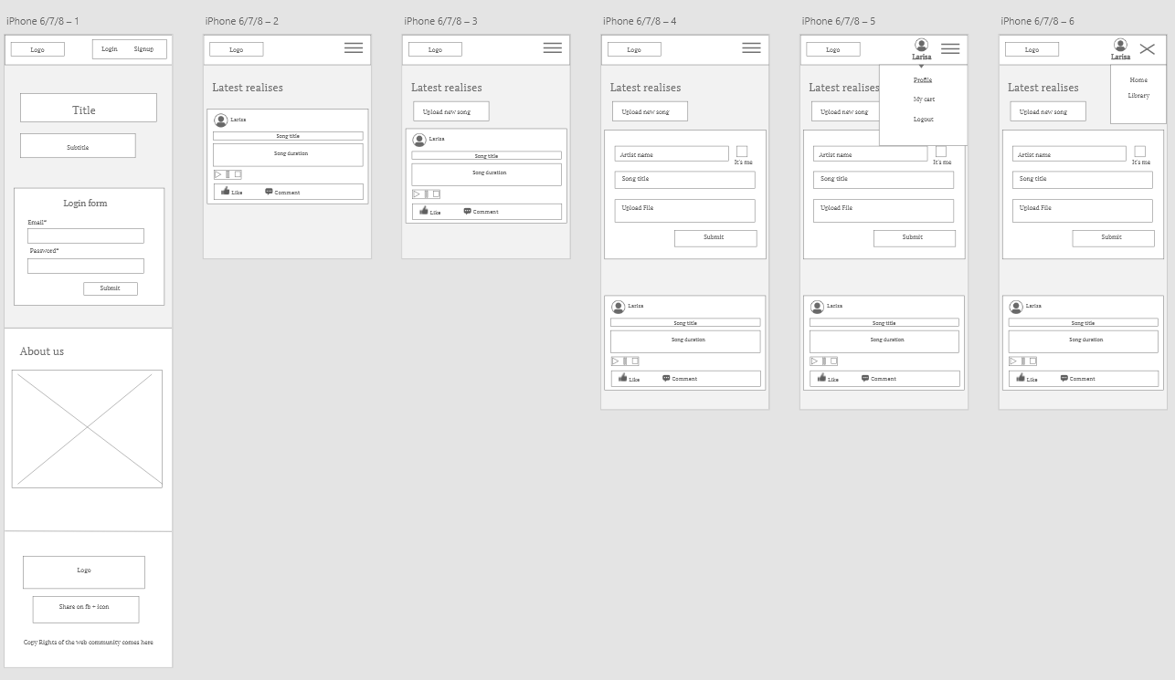

Link to the first recorded usability test: <https://youtu.be/nZoxE4gXHsc> based on paper prototype.

Links to the three prototypes that were dine to find the best approach of the digital solution:

1. <https://projects.invisionapp.com/prototype/rominimal-ck31unspi00bch1014xn2hl2o/play/50b947ba>
2. <https://xd.adobe.com/spec/e2715c2c-3f64-4d9b-7df7-37ec34745c1b-9440/>
3. <https://xd.adobe.com/view/73312085-460c-4b45-4215-69d7ca3bcfd4-0500/>

# Design Brief

Design Brief

*I. Background Overview*

Microhouse, tech-house or sometimes just minimal, are subgenres of house music strongly influenced by minimalism and 1990s techno.

Minimal music is a form of [art music](https://en.wikipedia.org/wiki/Art_music) that employs limited or minimal musical materials.

Rominimal, on the other hand, has a particular sound purveyed mostly by Romanian artists that draws thousands of people to never-ending parties in their home country and to festival stages abroad.

*II. Objectives*

The apps main objectives are to create an online community where producers post their music productions and the users get to listen and own the latest releases from their favourite DJs and discover many others.

III. Target Audience

As previously mentioned, Rominality’s target audience is between the ages of 18 to 40 whom appreciate simple and groovy tunes which aren’t found on popular streamlining platforms. They are students or working class professionals who enjoy social events, meeting and connecting with others and discovering new music. They are both male and female however the main demographic is men.

## 

## Moodboard

When the process of developing the visual identity began, research was focused in two main areas:

* The music style
* The style of the individuals that listen to it

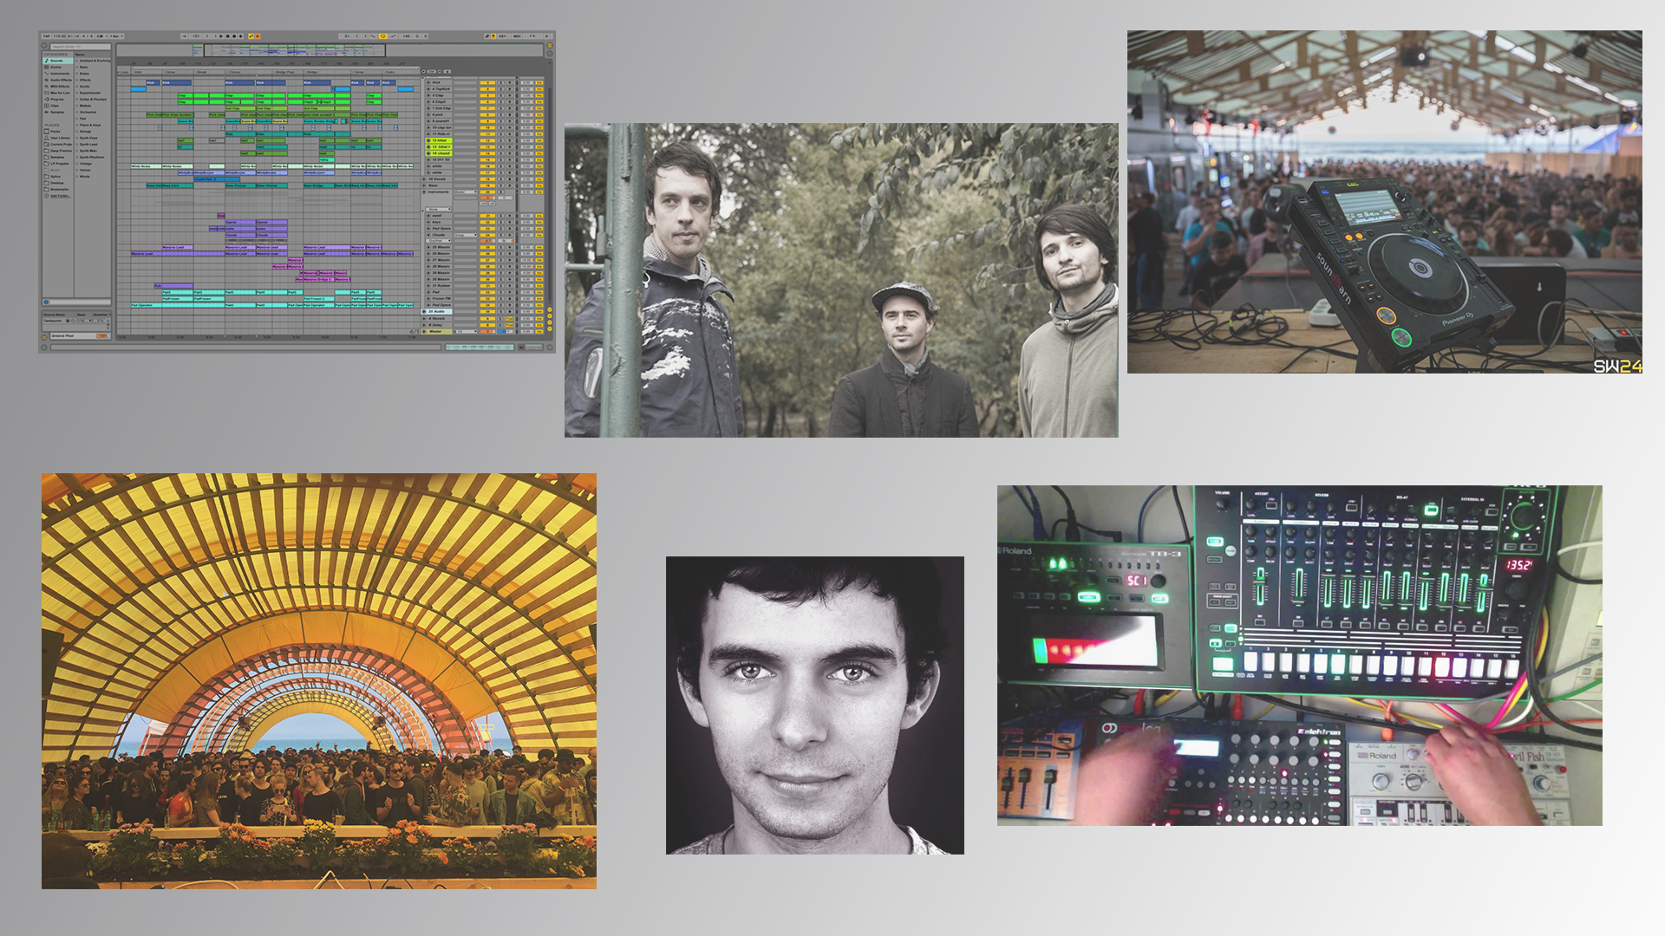

## Evolution of the Logo

We started with 3 variants of the logo and worked on all of them in order to define a specific and clear design for our web application.



Upon brainstorming, discussing, seeking opinions and completing research; we concluded none of them are cohesive with the latest version of the design.

Together we agreed that a new and remastered design was needed, ideally cleaner and simpler. The inspiration for this logo came from ROLAND which is the leader on the market for synthesizers and keyboards.

Having the fourth design of the logo we needed a specialist to provide us with feedback. We reached out to a graphic designer to share insights on our logos. We received good feedback from the expert review, but as expected, the latest version of the four was the most appreciated and the expert said it best suits the design.

Final Logo



One of the hardest challenges facing any marketing professional is picking a logo to represent the brand. Whether it is about rebranding or launching a project, picking a logo is a challenge because very often the expectations are to do several things:

- be distinctive and memorable

- reflect what the project is about or the market it serves

- convey brand personality

In order to find out if these aspects are achieved, a ‘5second test’ was conducted with several questions.

The ‘5 second test’ is a simple usability test to optimise the clarity of your designs and improve conversion rates by measuring people’s first impressions.

5 second test questions

1. What is the name of the company?
2. What do you think the company is doing?
3. What is your gender?
4. How old are you?

As the name of the project is written in the logo, a rate of 100% from the participants knew the answer is ‘rominimal’.

The second question was answered with a rate of 78% that the company is music related.

The last two questions had an answering rate of 52% males and 48% females, 61% having ages between 18 and 25 years old, 29% with ages between 26 and 30 years old, and with a rate of 10% ages above 30 years old.

The most fundamental function of a logo is giving the business/project a unique mark that differentiates the client from other businesses/projects. Another important function of a logo is to provide the customer with some information about the company: it can communicate the industry you exist in, the service you provide, your target demographic. Rominality is a combination between “rominimal” and “spirituality”. For a long time studies have been conducted to determine the nature of the relationship between spirituality and music-base emotions.

The logo is simplistic, minimalist and formed entirely by text. The text is written in Deadman Font, with a clean, minimalist sans-serif typeface. The font is similar to the ones used by ROLAND on its music products, ROLAND being one of the main manufacturers of hardware for techno and minimal music producers.

Practical requirements of trademarks

* Visibility - the logo can be seen when and where it should be seen because the graphic qualities ensure that the mark distinguishes itself from its surroundings so it facilitates fast identification.
* Competition - the trademark distinguishes itself from its surroundings and also from other marks used by competitors and other enterprises.
* Simplicity - the trademark is simple in its concept and therefore easy to understand.
* Black and white - the trademark is recognizable in black and white
* Fashionability - the trademark is fashionable

Pronunciation - the word isn’t sounding like any obscene or otherwise unwanted word or sound.

## Style Tile

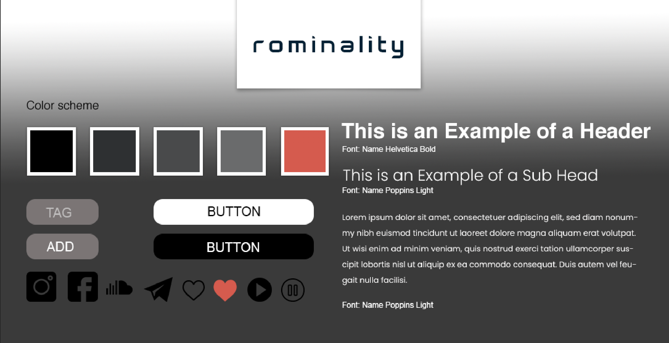

Style tiles are a design deliverable which visually represent and communicate the overall essence and feel of the brand and web page. It includes key components such as colours and fonts and is required alongside the wireframe and mockups to bring the design to life.

The development of the colour scheme over the course of the design process required consolidation between the music and the style of the individuals that listen to it and our knowledge of user-interface design. After analyzing, doing research and gaining inspiration from the original design of the TR-808, we settled upon the colour scheme because it is simplistic, dynamic and the contrast between black/white and grey/red represents duality.

The colour palette comprises of tones from black to white and to create a contrast with additional ranges of red.

The colour black has some powerful effects and can be associated with a sophisticated lifestyle, but also with power, elegance and mystery. Black is a mysterious colour that is typically associated with the unknown. It also affects the mind and body by helping to create an inconspicuous feeling, boosting confidence in appearance and increasing the sense of potential and possibility. The black colour is also associated with the underground music culture, most of the events being held in clubs with a very diffuse light, almost nonexistent.

White is associated with purity, virginity, light, goodness, sincerity and perfection. This colour represents a successful beginning. The colour white affects the mind and body by aiding in mental clarity, creating feelings of new beginnings and renewal. White is used in contrast with black for a better readability, user-friendly way.

Red is the colour of energy, passion and action. The colour red is a warm and positive colour associated with our most physical needs and our will to survive. Red is energizing, it excites the emotions and motivates us to take action.

The content is displayed on a grey-black gradient background on a 12 columns width grid system so it keeps the same structure on different screen layouts. On the sides there is negative space in order to create a break in the page, to highlight centralised messages, to direct the flow of the page and make specific elements ‘pop’.

The photos used on the website are edited with Adobe Photoshop, a powerful tool and a raster graphics editor developed by Adobe Systems, together with Procreate app and Adobe Lightroom on iPad.

For the typography, a font called Helvetica with font size selected for various parts of the website, more specifically, for the h1 with a size of 75px. Helvetica is a sans serif font with a strong and captivating readability and it was picked in order to send a message to the users in a friendly, elegant way.

For the subheadings and paragraphs, a font called Poppins with a weight of light and size of 45px for better readability. Poppins is also a sans serif, and it’s used to resemble the elegant and minimalist mood but in a futuristic and stylish way according to actual trends.

## 

## Mock Ups

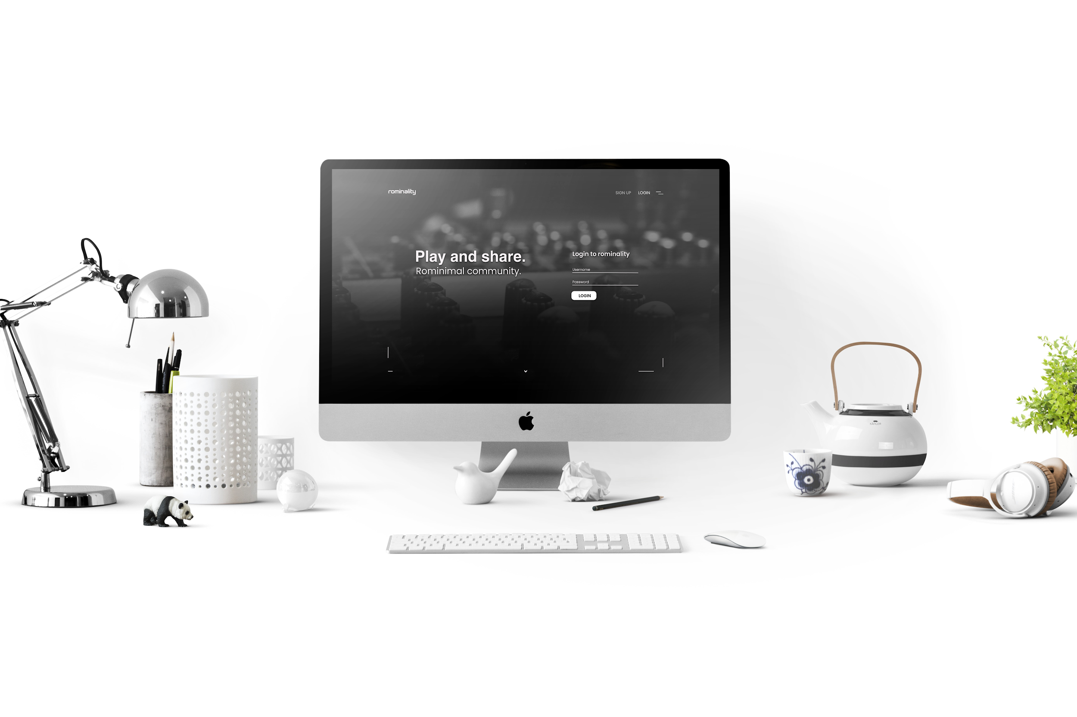

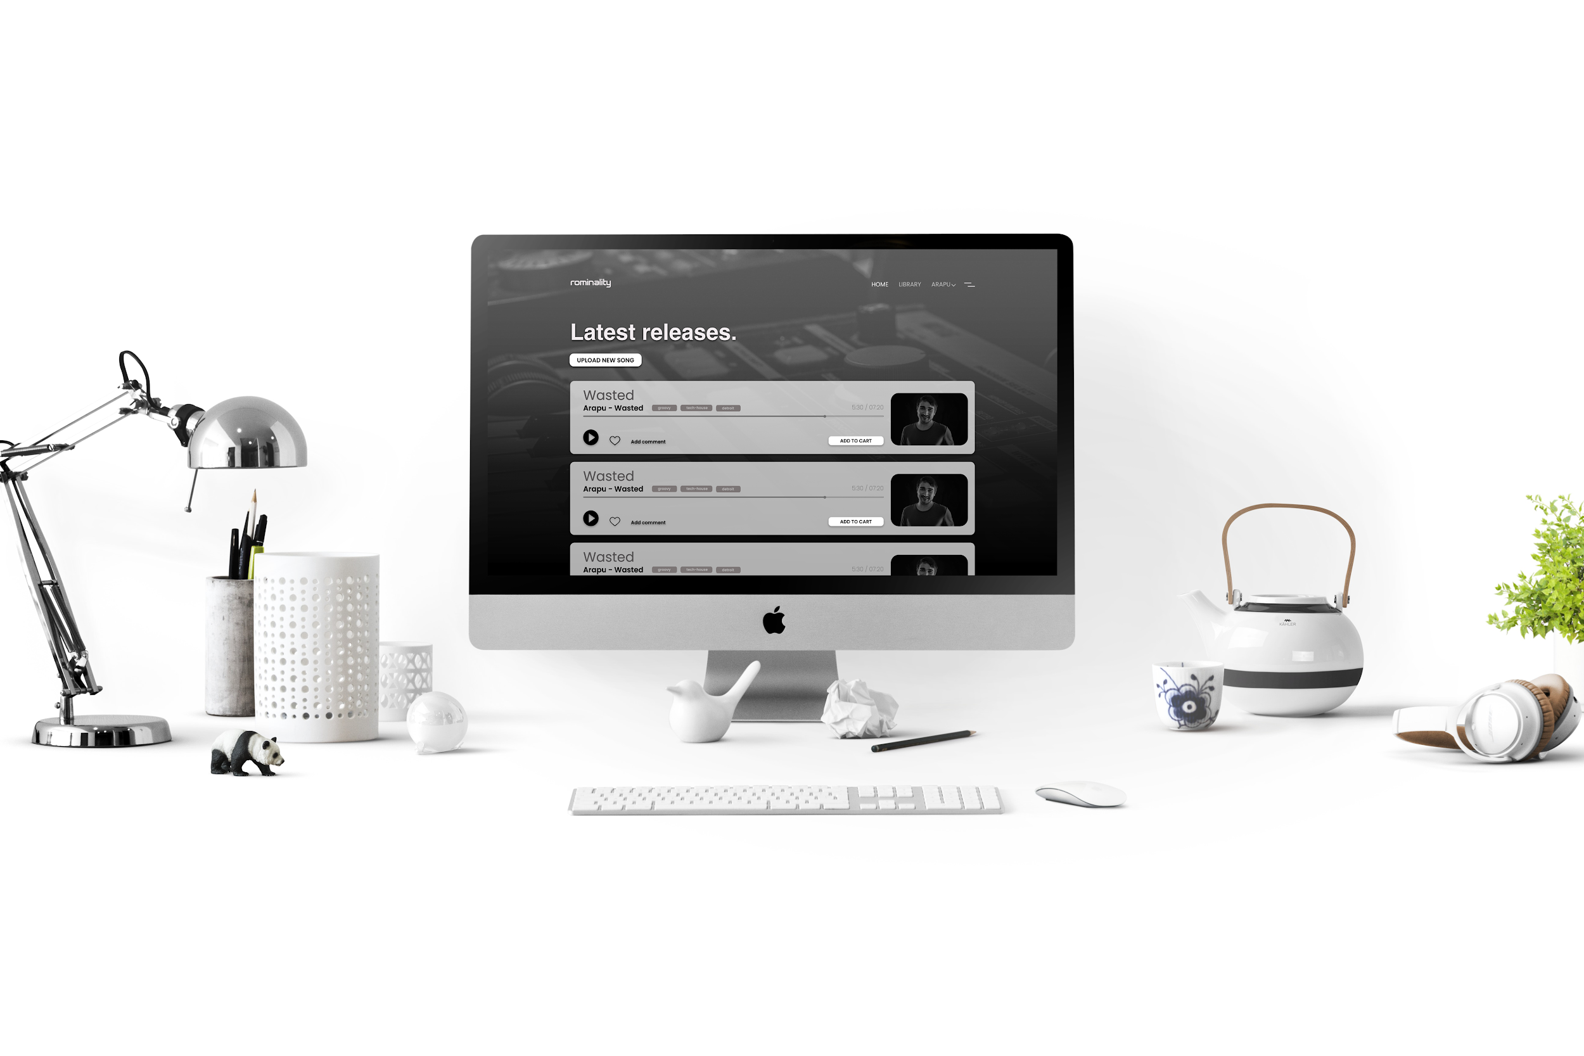

# Testing

In order to check if our initial design, functionality and site performance is as expected, we conducted several tests with real potential users.

We used 5 seconds test and BERT test and when needed we made use of an expert review test. This was done in order to make sure the design captures the attention of the user and the digital solution is being developed with the users needs at the forefront.

For testing the usability and functionality of the web application, we used Think aloud test and Card sorting test.

Think Aloud Test

First test provided by us is Think aloud test; a 25 year old male that resides in Denmark. He was given a certain number of tasks to accomplish in order to test the usability of the solution. The questions were:

1. Sign up as a new user

2. Login a a producer

3. Go to your library of music

4. Upload a new song

5. Update your profile

6. Checkout your cart

7. Logout

Link to the recorded usability test:<https://youtu.be/nZoxE4gXHsc> based on paper prototype.

After this test we concluded that the flow of the website is clear and simple for the user. The user did not get lost on the website and knew where to go in order to accomplish all the tasks.

BERT for Initial Designs

Bipolar emotional response testing (BERT) is a tool technique to test out one or many designs. The research is done by asking users to rate between two opposite characteristics in order to express their opinion about the design.

There are some important parameters that are important for Rominality’s site. Our desire is that the digital solution is very pleasant to our users and reflects a polished high quality webpage. At the same time, considering the target audience, our opinion and hope is that the website needs to look as professional as possible, as well as modern and simple.

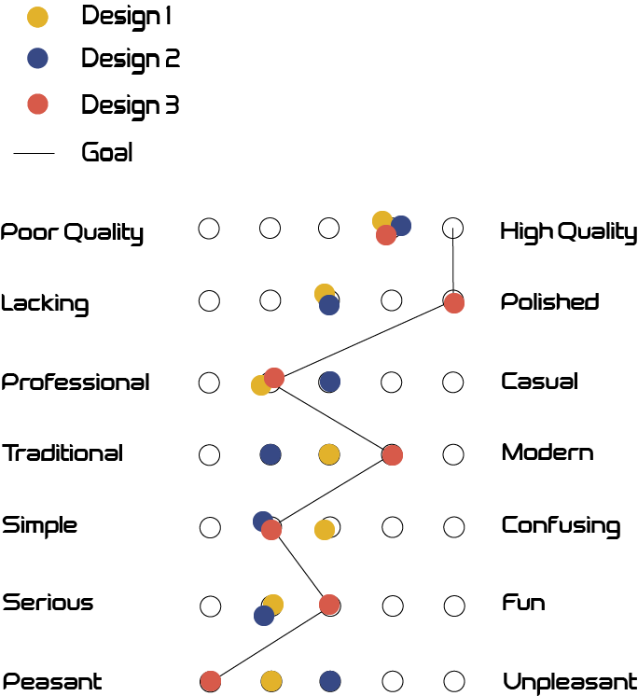

Based on the results of this test, design 3 was the closest to our goal, so it was considered the ideal one to continue development.

## 5 Seconds Test

The 5 seconds test gives you the opportunity to measure if the design communicates the wanted message easy and fast. In order to do it we used<https://app.usabilityhub.com/> and showed to the user a screenshot with the landing page for 5 seconds. Afterwards, the user answers a few questions to see if they remember important aspects of design and content.

We have tested all three of our designs in order to receive user’s feedback pertaining. In every test, the user where ask three questions:

1. What is the name of the website?
2. What do you think this website is about?
3. What do you think you can do on this site?

Most of the users knew the answer to the first question oscillated between “Rominality” and “Rominimal”. For the second question most of the users thought that the website is about some musical web app, few of them realised that it’s a web community for music lovers. The third question came with good answers from most of the users saying: login, signup, create a profile for a music web community. The third design received the most favourable feedback.

## Expert Review Test - Landing Page

The testing was done by a 25 year old male that works in design and development field and lives in Copenhagen. The feedback that we received from him was pretty good, he was satisfied and as a music lover he agreed that the colours and simplicity fits the industry. He mentioned the test may not be specific enough and suggested the logo to be bigger and contain something to draw in more attention.

## Card Sorting Test

Card sorting is a method used to help design or evaluate the information architecture of a site. In a card sorting test, participants organise topics into categories that make sense to them and they may also help label the groups. Card sorting helps understanding the users expectations and understanding of the topics.

Users were given topics like “Home”, “Library”, “My profile”, “My cart”, “Login”, “Logout”, “Signup” and they had to arrange them in the most “correct” order. The test was conducted on a number of 8 participants. A rate of 90% of the users that participated in the test arranged the topics in the following order:

* When the website is accessed: Signup / Login
* After the user logged in: Home / Library / User name with dropdown to My profile / My cart / Logout

Because of the results of the card sorting test, we concluded that the information architecture of the website should keep this flow as it seemed to be “natural” in most of the cases.

## System Usability Scale

The System Usability Scale provides a “quick and dirty” reliable tool for measuring the usability. It consists of a 10 item questionnaire with 5 response options for respondents from strongly agree to strongly disagree. This allows us to evaluate a wide variety of products and services, including hardware, software, mobile devices, websites and applications.

The test was conducted on a number of 7 participants, who were asked the following questions and gave the following answers:

1. I think that I would like to use this system frequently.  
    5 out of 7 answered “strongly agree”
2. I found the system unnecessarily complex.  
    6 out of 7 answered “strongly disagree”
3. I thought the system was easy to use.  
    6 out of 7 answered “strongly agree”
4. I think that I would need the support of a technical person to be able to use this system.  
    7 out of 7 answered “strongly disagree”
5. I found the various functions in this system were well integrated.  
    5 out of 7 answered “strongly agree”
6. I thought there was too much inconsistency in this system.  
    4 out of 7 answered “strongly disagree”
7. I would imagine that most people would learn to use this system very quickly.  
    7 out of 7 answered “strongly agree”
8. I found the system very cumbersome to use.  
    7 out of 7 answered “strongly disagree”
9. I felt very confident using the system.  
    6 out of 7 answered “strongly agree”
10. I needed to learn a lot of things before I could get going with this system.  
     6 out of 7 answered “strongly disagree”

In order to find the final score of the SUS, we used an online SUS calculator and got a score of 82.5 <https://uiuxtrend.com/sus-calculator/>

# The Website

Given that the web community wants to increase visibility for producers and help them earn profit, our idea is based on some rules.

There are 2 types of users: normal user and producer. As a user you can register, buy music and listen to a 30 second preview of each song that has been uploaded. If a users wishes to add a full song to their library, they must purchase the song. In addition, users can update their profiles and become a producer if desired. As a producer, all the same functions are available and additional you can upload music and keep track of it.

For future development, we, as a team, decided it would be beneficial to have the opportunity to have a premium account. Some features may include listening to the full song once or twice as opposed to simply 30 seconds. Afterwards, a purchase would be necessary in order to keep the track in the users library.

# Technologies

We have decided to go with php files that includes html tags and all sql queries, vanilla Javascript and vanilla css. This was chosen for the simplicity of the website and because we wanted the solution to be clean and include only what is needed so the overall performance is better and the website is faster.

Installation guide

We have added an installation guide in the root folder called README.md which explains how to set up our project on a virgin test environment with full operational capabilities.

# Concussions

Rominality is currently a web community for rominimal music lovers which will be further improved and continuously developed in order to provide a concrete solution. User testing showed us that the initial idea and basic setup is promising and has the potential to be a great and valuable product throughout the music community.

After finishing all the planned functions, we believe that Rominality will be a great product and widely used. In addition to the future improvements which will be implemented, Rominality is sure to be a hit.

# Bibliography

1. Post. (2019, March 14). Retrieved November 26, 2019, from <https://www.assonantcircles.com/post/the-ro-minimal-story>
2. Mihai, C. (2017, December 16). Catalin Mihai. Retrieved November 26, 2019, from <https://djsets.ro/index.php/ro/stiri/244-sunwaves-23-au-fost-anuntate-primele-detalii-despre-festival-2>
3. Burns, W. (2014, July 31). Is Electronic Dance Music The Ticket To Reach Millennials? Retrieved November 26, 2019, from <https://www.forbes.com/sites/willburns/2014/05/26/is-electronic-dance-music-the-ticket-to-reach-millennials/#2437558965da>
4. Grate Rachel is a writer for Eventbrite, R. (2017, August 15). 3 New Stats About Millennials' Taste in Live Music - Eventbrite. Retrieved December 3, 2019, from <https://www.eventbrite.com/blog/millennials-trends-in-music-data-ds00/>
5. Friedman, Z. (2018, June 27). Why Are Millennials Still Living With Their Parents? Retrieved December 6, 2019, from <https://www.forbes.com/sites/zackfriedman/2018/06/27/millennials-student-loans-housing/#428f34e226aa>
6. Landrum, S. (2017, May 12). Millennials Are Relying On Music More For A Better Workday. Retrieved November 26, 2019, from https://www.forbes.com/sites/sarahlandrum/2017/05/12/millennials-are-relying-on-music-more-for-a-better-workday/#771ef0f1736e